INVOICE

|  |  |  |  |  |  |  |
| --- | --- | --- | --- | --- | --- | --- |
| Full Name: Rushabh Prakash Arbat  Mob No.: 8975348428  Email: rushabharbat97@gmail.com  Address: SBI colony,Shegaon  Pan Card: DSCPA5979M | |  |  | | --- | --- | | Invoice No. | 01 | | Invoice date | 28/10/2021 | |  |

|  |  |
| --- | --- |
| Bill To:  Neova Solutions Pvt. Ltd.  P3-603, Pentagon Tower,  Magarpatta, Hadapsar,  Pune- 411028 |  |

|  |  |
| --- | --- |
| Description | Amount |
| Fees for Development Services rendering as Software Engineer - Intern  Date: 11th Oct to 31st Oct 2021 | 9484 |

Bank Details : STATE BANK OF INDIA,SHEGAON

Account Holder : Rushabh Prakash Arbat

Account Number : 39528740448

IFSC code : SBIN0002176

Branch : Shegaon

Thank you for your business.

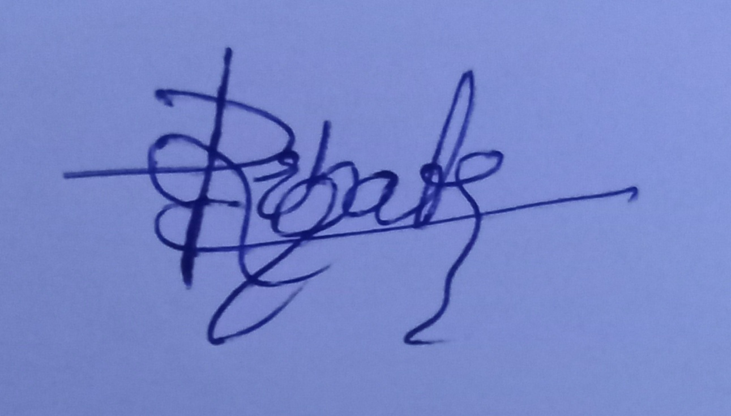

Signature

Name : Rushabh Prakash Arbat